ALTERNATIVE WAY TO CHECK EMAIL OR FIND INVALID EMAIL ADDRESSES

STEP 1:

* Gather all customer records on one page

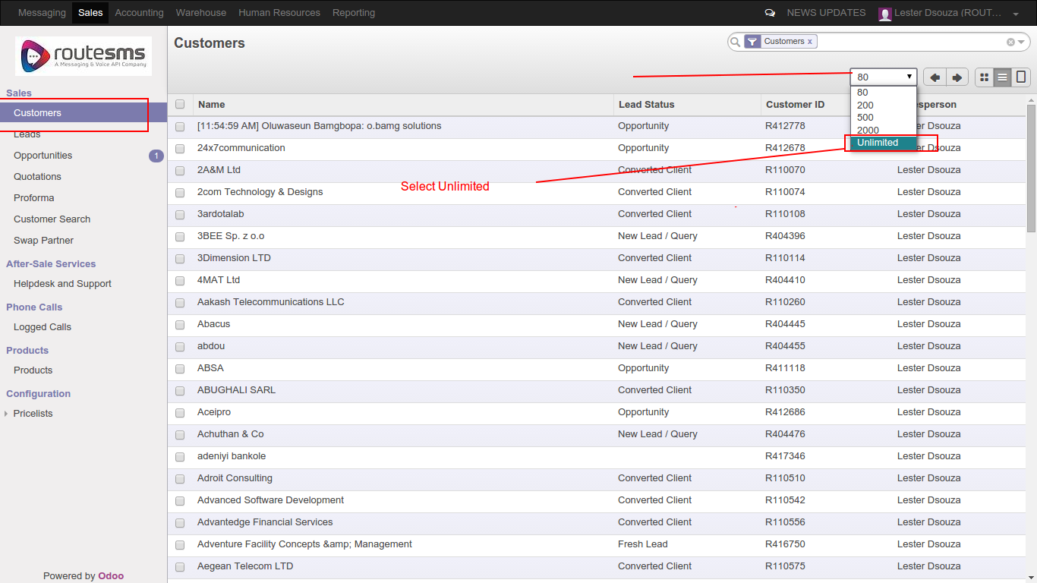

STEP 2:

* Select all records at once and hit export buttom

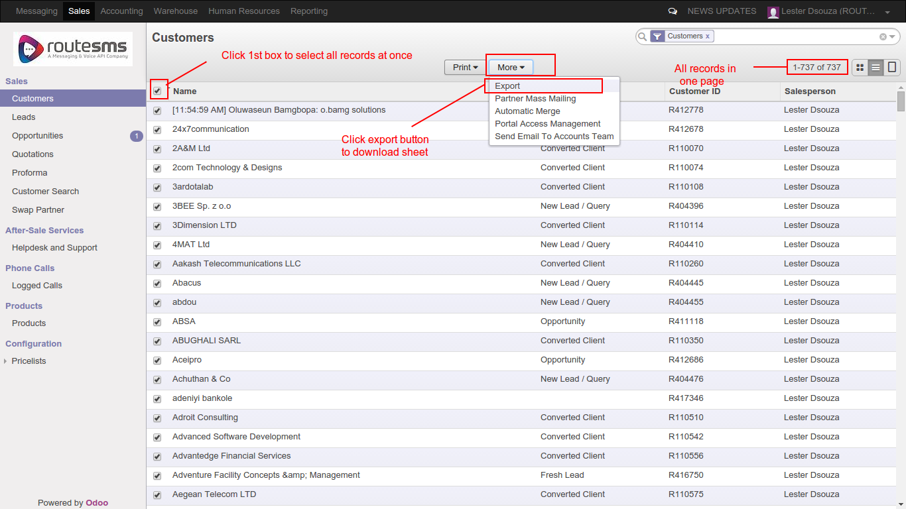

STEP 3:

* Select existing template from template list

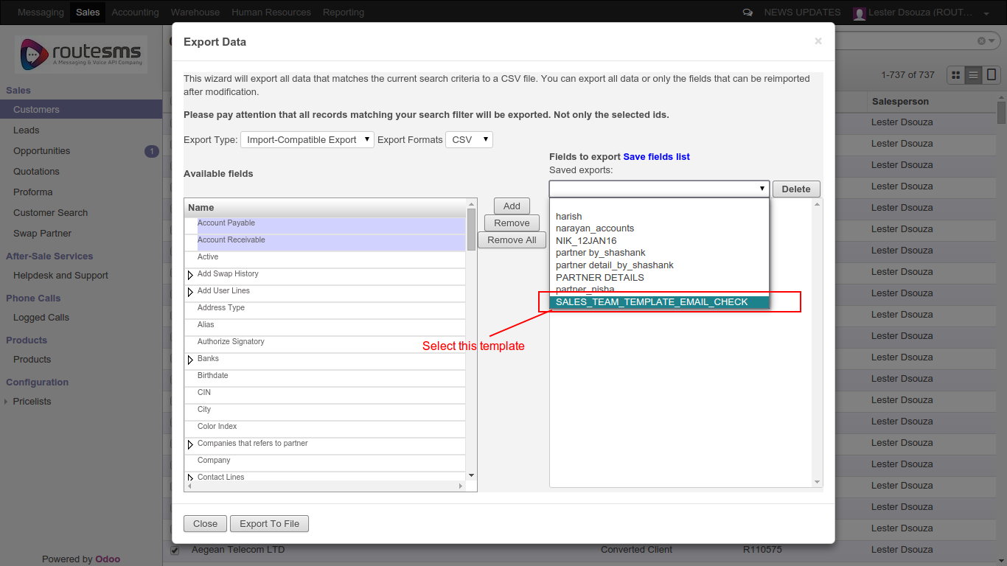

STEP 4:

* Click export to file button to download the excel file which will contains customer details

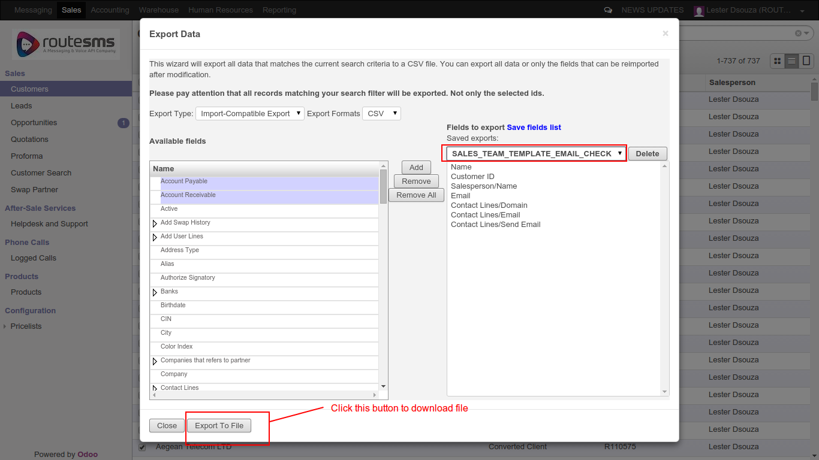

STEP 5:

* Open Downloaded file

* Check email address details both primary and secondary

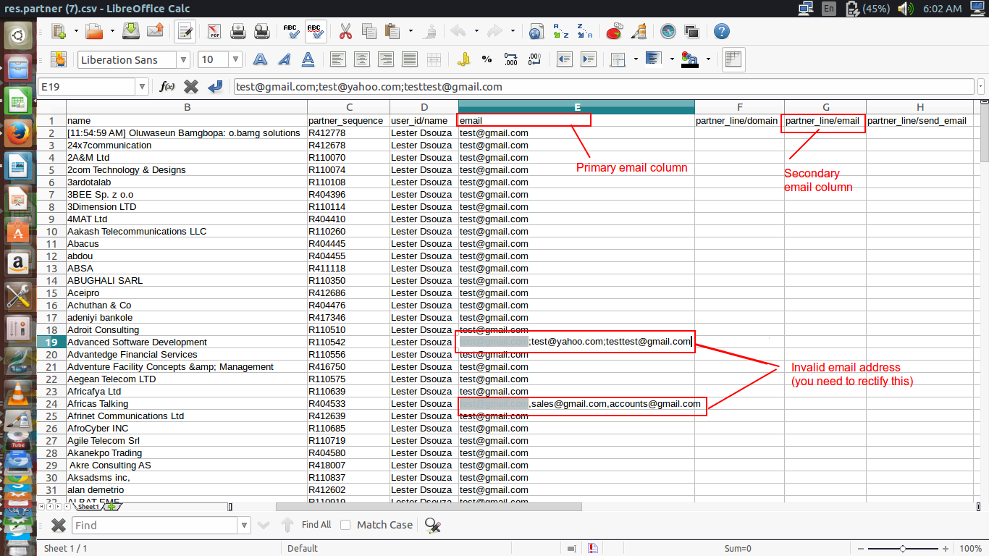

THANK YOU

